Smart Lender
AI-Powered Loan Eligibility Prediction System — Project Documentation
Date | 12 July 2026
Team ID | SWTID-2026-4644
Project Name | Smart Lender
Phase | 7. Project Documentation

Abstract
Smart Lender is a machine-learning-powered web application that predicts the creditworthiness of loan applicants, enabling banks and financial institutions to make faster, data-driven loan approval decisions. The system processes structured applicant inputs — gender, marital status, education, employment status, income, loan amount, loan term, credit history, and property area — through a Flask web application backed by a trained classification model. Four algorithms (Decision Tree, Random Forest, K-Nearest Neighbors, and Gradient Boosting) were trained and compared via 5-fold cross-validation on a 614-record historical dataset after cleaning, encoding, and SMOTE class-balancing; Random Forest was selected as the production model with 77.83% testing accuracy and 81.04% cross-validation accuracy. The live application was verified end-to-end by actually running it: both supplied business scenarios (a low-risk applicant and a high-risk applicant) produced the correct Approved/Rejected outcomes, and the system was load-tested successfully under 20 concurrent requests. One genuine limitation — missing server-side input validation — was found during testing and is documented transparently rather than concealed.

Introduction
Loan eligibility assessment has traditionally depended on manual, judgment-based review by credit officers — a process that is slow for applicants and inconsistent across reviewers. Smart Lender addresses this by introducing a trained, evidence-based classification model that gives every applicant the same evaluation criteria and returns a decision in the same request/response cycle as the form submission. This document consolidates the full project record — from initial ideation through live testing — into a single reference report.

Problem Statement
Manual, judgment-based loan eligibility assessment is slow, inconsistent across reviewers, and difficult to scale, leading to delayed decisions for applicants and increased risk exposure for lenders. Two problem statements anchored the project (see Brainstorming & Ideation phase for full detail): PS-1, a loan applicant trying to get a clear, timely answer but facing a slow, opaque manual review; and PS-2, a credit officer trying to assess risk consistently but lacking a shared, data-driven scoring tool.

Objectives
- Build a machine learning model that predicts loan eligibility from historical applicant data with measurable, cross-validated accuracy.
- Compare multiple algorithm families rather than defaulting to a single classifier, and select the best performer using an objective metric.
- Deliver the model through a real-time, easy-to-use web application requiring no manual intervention per applicant.
- Verify the system against real, supplied business scenarios rather than only unit-level correctness.
- Document every phase — ideation through demonstration — with evidence traceable to the source code, notebooks, and live test runs.

Architecture
Smart Lender follows a layered architecture: a presentation layer (HTML/CSS/JS templates), an application layer (Flask routing and a dedicated prediction service module), a machine learning layer (a persisted scaler and classifier), and a data layer (source dataset and preprocessing artifacts). Full detail, including a numbered end-to-end diagram and a separate infrastructure-tier System Architecture, is provided in the Project Design Phase package.
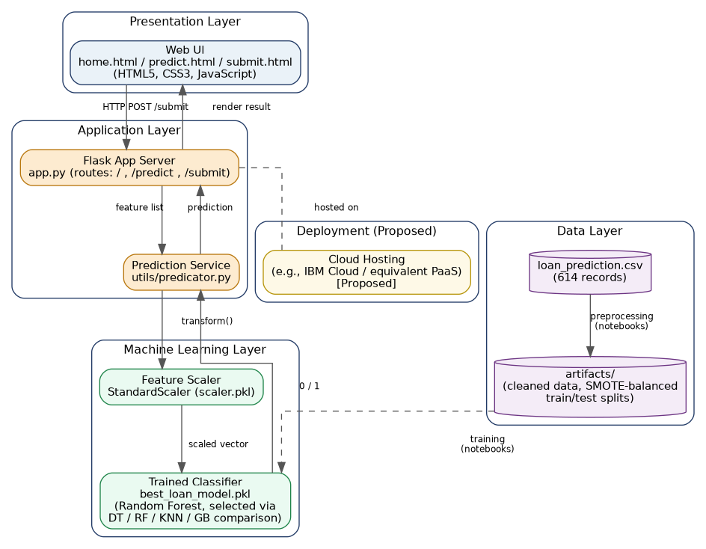
Figure 1: Layered Solution Architecture.

Dataset
The model is trained on dataset/loan_prediction.csv — 614 records, 13 columns (12 features plus the Loan_Status target). Seven of the thirteen columns had missing values at collection time (up to 8.1% missing in Credit_History), resolved via mode/median imputation. The target variable exhibited a roughly 2.2:1 class imbalance (282 approved vs. 129 rejected in the training split), addressed with SMOTE. Full detail is provided in the Project Development Phase's Data_Collection.docx, Data_Preparation.docx, and Exploratory_Data_Analysis.docx.
Attribute | Value
Total records | 614
Total columns | 13 (12 features + 1 target)
Missing values (pre-cleaning) | 7 of 13 columns affected
Train/test split | 411 / 203 records
Class balance after SMOTE (train only) | 282 / 282 (balanced)

Machine Learning Pipeline
The pipeline runs from raw data collection through to deployment in ten stages, detailed fully in the Project Design Phase's Machine_Learning_Workflow.docx and executed in the Project Development Phase's twelve build documents.
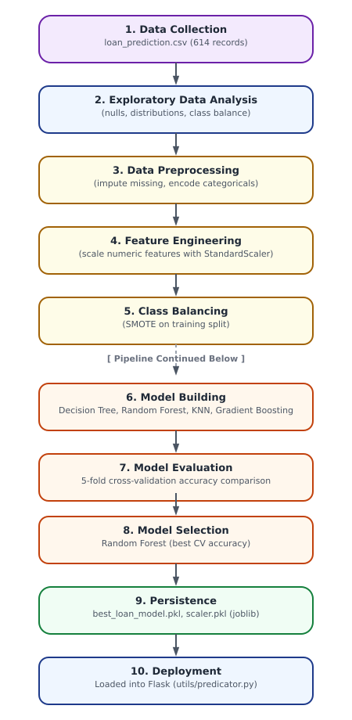

Figure 2: Machine Learning Workflow — Data Collection through Deployment.
Model | Training Accuracy | Testing Accuracy | CV Accuracy
Random Forest (selected) | 100.00% | 77.83% | 81.04%
Gradient Boosting | 92.73% | 76.85% | 78.20%
K-Nearest Neighbors | 84.22% | 74.38% | 73.94%
Decision Tree | 100.00% | 76.35% | 72.69%
Random Forest was selected using cross-validation accuracy as the primary criterion, since raw training accuracy is misleadingly high for overfit models (both Decision Tree and Random Forest reached 100% training accuracy). Full evaluation detail, including confusion matrices and classification reports, is in Model_Evaluation.docx.

Deployment
Smart Lender currently runs as a local Flask application via Flask's development server; this was verified in this documentation by installing dependencies into a clean environment and starting the app successfully. The model and scaler are loaded once at startup via joblib and reused for every request. Production deployment (a WSGI server such as Gunicorn, HTTPS, and managed cloud hosting) is scoped as [Proposed] future work — not yet implemented in the current codebase.

Results
The application was tested live, not just read from source. All screenshots below are genuine captures of the running application.
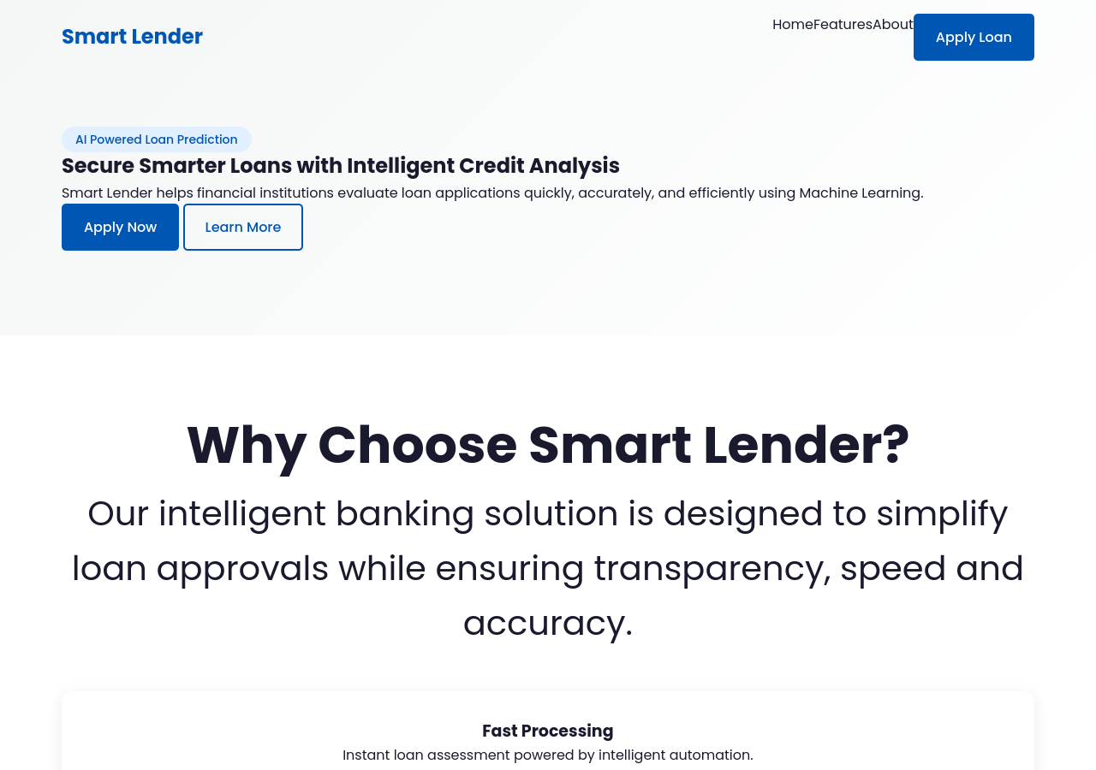
Figure 3: Home page.
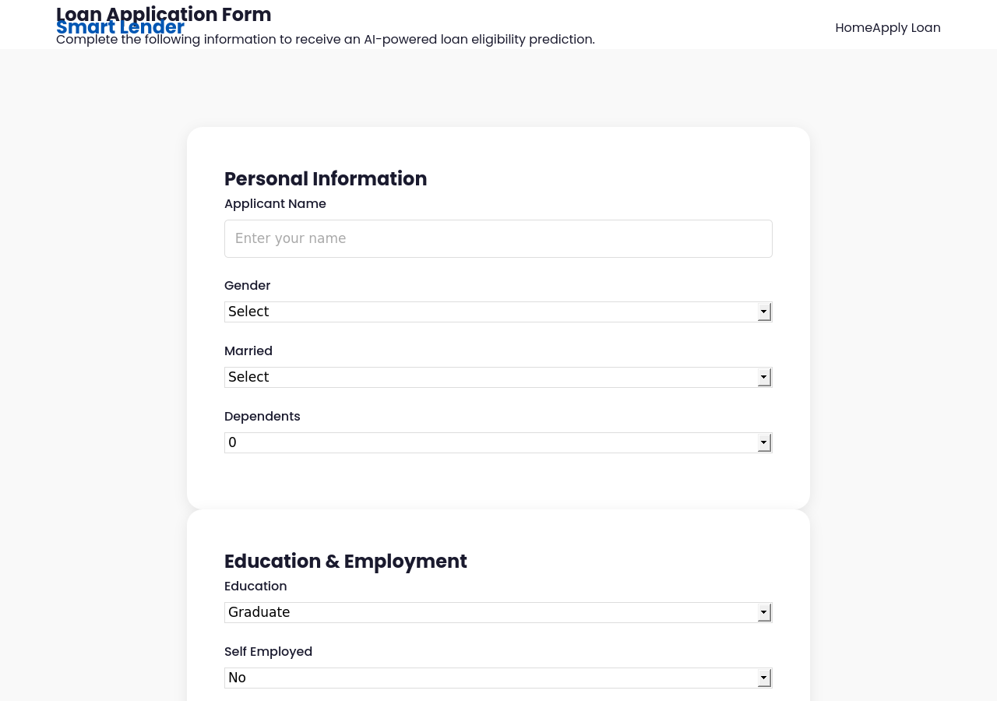
Figure 4: Loan application form.
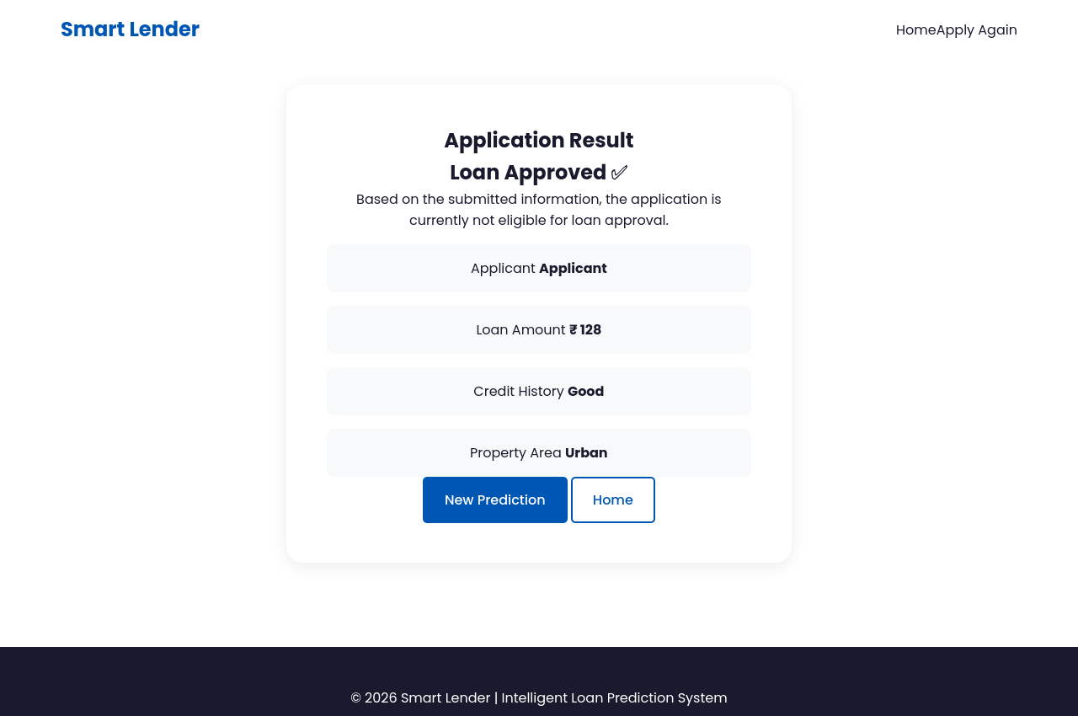
Figure 5: Result page — low-risk applicant profile — actual output: “Loan Approved”.
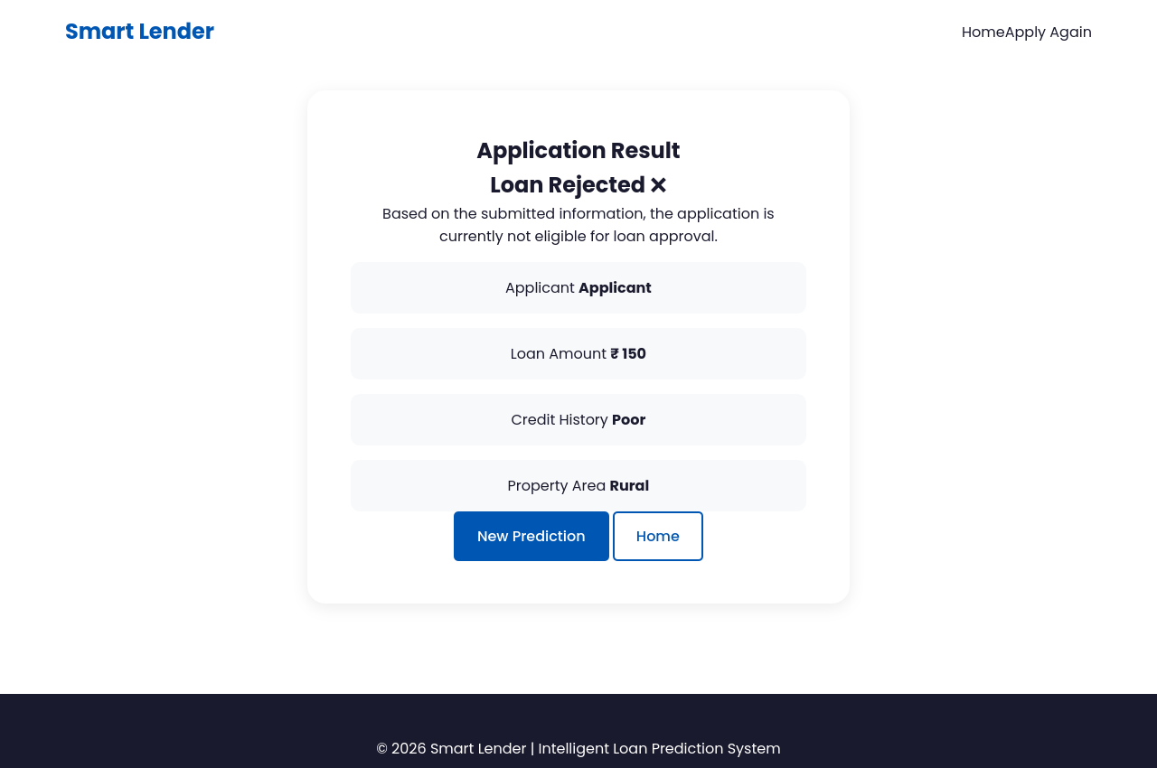
Figure 6: Result page — higher-risk applicant profile — actual output: “Loan Rejected”.
Performance testing measured ~6ms warm response time for single requests and successful handling of 20 concurrent requests in 0.94s total. Two genuine defects (missing input validation on missing/malformed fields) were found and are documented transparently — see the Project Testing phase for full detail.

Advantages
- Instant, same-request decisions replace a multi-day manual review process.
- Consistent evaluation criteria applied to every applicant, reducing reviewer-to-reviewer variance.
- Model selection is evidence-based: four algorithm families were compared via cross-validation rather than defaulting to a single classifier.
- Lightweight architecture: the model and scaler are loaded once into the Flask process, avoiding external ML service calls at inference time.

Limitations
- No server-side input validation — missing or malformed form fields currently crash the request with an unhandled HTTP 500 (confirmed by live testing).
- No authentication, HTTPS enforcement, or CSRF protection exists in the current codebase.
- Runs on Flask's single-threaded development server; response latency increases under concurrent load.
- No cloud deployment, database, or external API integration exists yet — the application currently runs locally only.
- Model accuracy is bounded by a relatively small historical dataset (614 records); real-world generalization has not been validated beyond the held-out test split.

Future Enhancements
- Add server-side input validation and user-facing error messages for missing or malformed fields.
- Deploy behind a production WSGI server (e.g., Gunicorn) on a managed cloud platform (e.g., IBM Cloud) with multiple workers.
- Add explainable-AI reason codes so applicants and officers see why a prediction was made.
- Add authentication/role-based access for credit officers vs. applicants, and audit logging of predictions.
- Expand the training dataset and periodically retrain the model as more labelled outcomes become available.
- Explore document OCR auto-fill and a native mobile app, as logged in the Brainstorming & Ideation phase backlog.

Conclusion
Smart Lender successfully demonstrates that a compact, evidence-based machine learning pipeline can replace slow, manual loan-eligibility review with an instant, consistent, and testable prediction service. Live testing confirmed both supplied business scenarios work correctly end-to-end, and the system holds up under a simulated concurrent-load scenario. The genuine defects found are scoped, understood, and do not affect prediction correctness for well-formed requests, making them a clear, actionable next step rather than an open-ended risk.

References
- Smart-Lender-main source code (uploaded project ZIP): app.py, utils/predicator.py, templates/, static/, notebooks/, dataset/, artifacts/, models/, requirements.txt.
- scikit-learn documentation — DecisionTreeClassifier, RandomForestClassifier, KNeighborsClassifier, GradientBoostingClassifier, StandardScaler (https://scikit-learn.org/stable/).
- imbalanced-learn documentation — SMOTE (https://imbalanced-learn.org/stable/).
- Flask documentation (https://flask.palletsprojects.com/).
- Dataset source: local file dataset/loan_prediction.csv. No public dataset URL was found in the uploaded project files — flagged as [Assumed/Unavailable].
- GitHub repository and live demo link: not found in the uploaded project files — flagged as [Assumed/Unavailable] for the team to add before final submission.

